**Lab Activity 10**

# **Subnetting a Class B Network**

**Objective:**

Subnetting is an important skill for anyone working in a subnetted network environment. As a network professional, you will be required to understand subnetting. Although subnetting will be covered in greater detail in later courses, it is important that students gain a solid foundational understanding in this class.

In this lab you will calculate the subnet mask, the subnet IDs, broadcast addresses and host ranges for a small class B network.

Once you have completed the lab, you will be able to:

* Subnet a class B network.

**Requirements:**

In order to complete this lab you will need:

* This lab will be done on paper.

**Activity:**

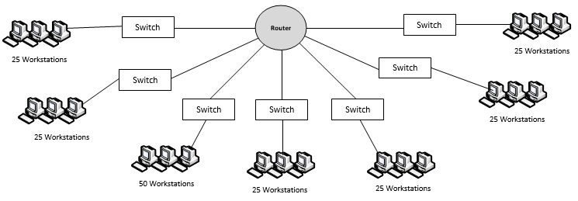In this activity you will calculate the subnet addresses, broadcast addresses, and host ranges for the class B network show below, with a Network Address of 172.16.0.0. Solve for the correct number of subnets.

172.16.128.1 – 172.16.159.254

172.16.96.1 – 172.16.127.254

172.16.64.1 – 172.16.95.254

172.16.192.1 – 172.16.223.254

172.16.160.1 – 172.16.191.254

172.16.32.1 – 172.16.63.254

172.16.0.1 – 172.16.31.254

172.16.192.0

172.16.160.0

172.16.32.0

172.16.128.0

172.16.96.0

172.16.64.0

172.16.0.0

1. How many subnets are in the network?______8______
2. What is the default subnet mask for a Class B network?__255.255.0.0__
3. Which octet will we be borrowing bits from?___3rd_____
4. How many bits would need to be borrowed from the host portion of the address to give you enough subnets?_3_
5. What subnet mask is required to borrow that number of bits?
   1. Binary: ____255.255.224.0___
   2. Decimal: 11111111.11111111.11100000.00000000
6. Determine the multiplier by looking at the right-most bit borrowed in the subnet mask, and calculating the decimal value of that bit.
7. What is the multiplier? _8192___
8. Using the above multiplier, determine the subnetwork addresses (subnet IDs): (Hint: Always start with 0)
   * + Subnet 1:____172.16.0.0________
     + Subnet 2: ___172.16.32.0_______
     + Subnet 3: ___172.16.64.0_______
     + Subnet 4: ___172.16.96.0_______
     + Subnet 5: ___172.16.128.0______
     + Subnet 6: ___172.16.160.0______
     + Subnet 7: ___172.16.192.0______
9. The last address on any subnet is the broadcast address. What are the broadcast addresses for each subnet?

| **Subnet Address** | **Broadcast Address** |
| --- | --- |
| **172.16.0.0** | **172.16.31.255** |
| **172.16.32.0** | **172.16.63.255** |
| **172.16.64.0** | **172.16.95.255** |
| **172.16.96.0** | **172.16.127.255** |
| **172.16.128.0** | **172.16.159.255** |
| **172.16.160.0** | **172.16.191.255** |
| **172.16.192.0** | **172.16.223.255** |

All of the addresses between the subnet ID and the broadcast address are your usable host addresses. What is the host address range for each subnet?

| **Subnet Address** | **Host Range** |
| --- | --- |
| **172.16.0.0** | **172.16.0.1 – 172.16.31.254** |
| **172.16.32.0** | **172.16.32.1 – 172.16.63.254** |
| **172.16.64.0** | **172.16.64.1 – 172.16.95.254** |
| **172.16.96.0** | **172.16.96.1 – 172.16.127.254** |
| **172.16.128.0** | **172.16.128.1 – 172.16.159.254** |
| **172.16.160.0** | **172.16.160.1 – 172.16.191.254** |
| **172.16.192.0** | **172.16.192.1 – 172.16.223.254** |

1. Label the network diagram, with the subnet IDs and the host ranges. Write the subnet ID next to the corresponding switch, and label each host range under the computers on each subnet.

**Deliverables:**

* Complete the lab and upload the completed document.